Getting Started

The V+ code used for this program was initially taken from the ROS industrial package, specifically under the adept_common package, specifically from a file called ros.v2. Links are below.

http://wiki.ros.org/adept_common?distro=groovy
http://swri-ros-pkg.googlecode.com/svn/branches/groovy/adept/adept_common/V+/ros.v2

The original code was altered to include functions for setting velocity, acceleration and tool length. The two main software components are the V+ code on the Adept controller and the ROS/OpenRAVE code on the connected workstation.

To build the code (in case of changes), go to the catkin_ws folder in the software's path and type “catkin_make install”. If you get permission errors, check that the executables in catkin_ws/install/lib are not created by root (if they are, delete them).

Adept Controller Start-up
- Turn on Robot Power via the switch on STU-3000 power box
- On Ubuntu machine, start a new terminal and connect to the controller with the terminal emulation program using “sudo minicom.” A minicom help screen can be reached by entering CTL-A Z.
- Controller will start booting, if prompted where to load from, select local disk (d)
- Load the robot code with “load ros.v2”. Severload ros.v2
- al programs will be listed as they are loaded into system memory.
- The robot must have high power enabled, do so with the “enable power” command. Ensure the key on the wired front panel is turned to the right before executing the command, or else E-Stop errors be triggered. When the command is issued press the white button on the panel.
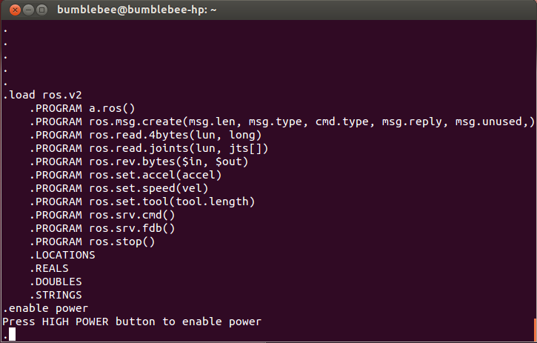
- Execute the program with “execute a.ros”. This will start the ros.srv.cmd program, which will listen for a socket connection to take commands from the computer. Once the ROS/OpenRAVE program is started, the controller print that it is connected to ROS.

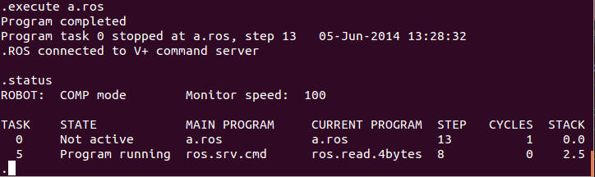
- After use, make sure to disable high power and clear main memory by turning the front panel key left and using the “zero” command respectively.

ROS/OpenRAVE startup:
- Start a new terminal on the connected computer. All relevant program code should be located in the catkin workspace, located in ~/catkin_ws. Source code is in ~/catkin_ws/src/osu_ros_adept/. Once built, code is copied and built to ~/catkin_ws/install. Before attempting to run the program the install setup file should be sourced with “source ~/catkin_ws/install/setup.bash”
- The project should have a roslaunch file, allowing it to be executed by the command “roslaunch osu_ros_adept adept_rave.launch”. Once executed there will be several debug and informative messages printed to the terminal, indicating the launch of ROS nodes and setup information from those nodes. Console will look similar to the image on the next page.
    - The joy_to_RAVE node requires root access to send commands to the servo board for hand control. There are different ways to resolve this, one of which is running roslaunch as root, which may require sourcing the setup file again. An alternative is to login as root and then exit, so the password is not required when joy_to_RAVE attempts to execute a command as root.
- After roslaunch finishes starting all relevant node an OpenRAVE window will open with the robot model on a table. Different robots or environments can be loaded by altering the RAVE_ADEPT.py file, specifically within the class initialization.
- It should be noted that simulated claw movement was not implemented in OpenRAVE. Though the claw won't react like the physical one, it will prevent the actual claw from slamming into the table. Implementing simulated claw motion will require modifying the kinbody file for the claw, located in ~/catkin_ws/src/osu_ros_adept/scenes/robot/trigrip.kinbody.xml
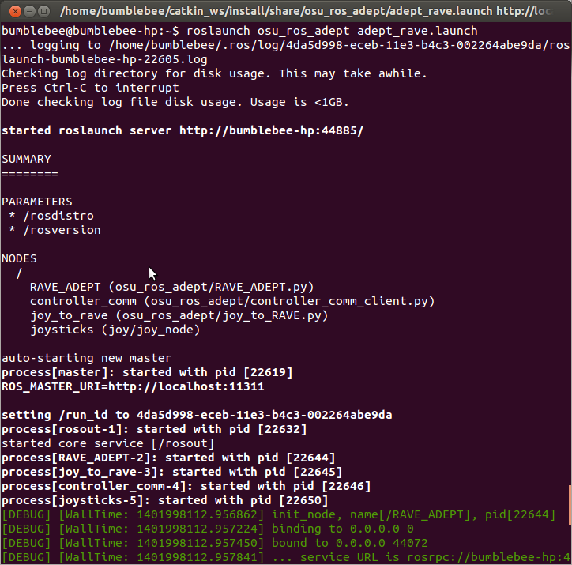
- Ensure a logitech gamepad is connected to a USB port. Explanations of how to control the virtual robot are below. It should be noted that claw control is temperamental, with the claw closing on its own at times. This could be due to a loose wire or short somewhere between the servo board and the hand, and has not been resolved as of June 2014.
- Additonally, manual entry of robot joints or performance parameters can be issued using a python script. This is executed by entering “rosrun osu_ros_adept manual_entry.py”. This script was originally used when work robot control with ROS began, and simply prompts for motion or parameters in a loop. USE AT YOUR OWN RISK WHEN SENDING MOTION COMMANDS THROUGH THE PROMPT, it is possible to damage the robot or hand if bad values are given, as the robot will not be aware of the table. Setting speed from here should be done with care, anything above 400 (mm per second) can cause fast enough motion to shake the table the robot is mounted on.

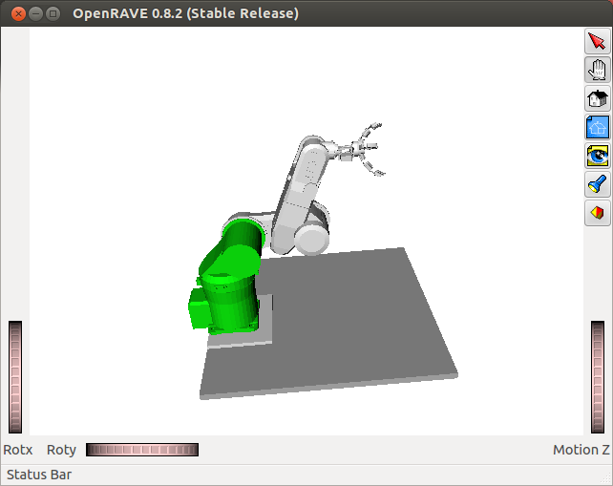
OpenRAVE window with Robot Model

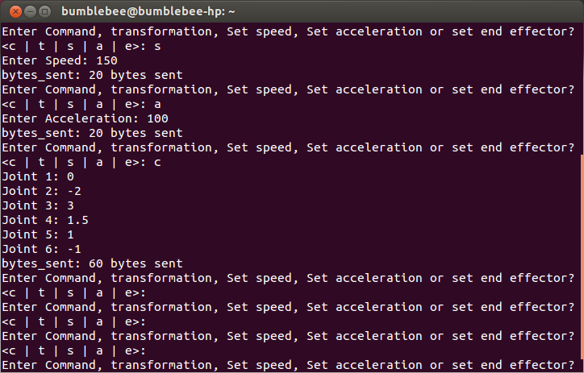
Manual Entry Prompt

Possible issues
- The minicom terminal may have to be configured. This can include selecting the correct serial port (usually /dev/ttyS0 although we have seen ttyS4; use “dmesg | grep tty” to see all open serial ports), speed (9600 baud), parity bit (None), data bits (8) and stop bit (1) (according to the Adept SmartController CX User Guide). Correct values can be found in the smart controller users guide.
- To enable power the key must be turned to the right on the wired front panel remote. Calibration may be needed with “calibrate” command.
- Code was not implemented to reconnect the socket in case of some error. In these cases, both programs will need to be restarted. ROS can be restarted by reissuing the roslaunch command. On the controller, abort and kill the ros.srv.cmd process and reexecute. PID should be 5 but can be found by issuing the “status” command.
- Using the socket requires a wired ethernet connection. The default IP of the controller is on the bottom of the case. The ethernet adapter on the host computer should be put on the same subnet as the controller, ie 172.16.X.X/16. For some strange reason, the controller will not bend to the main computer's will and demands to be on the 172.16.x.x subnet, thus you will need to configure the main computer's ethernet connection via the Edit Connections menu located under the network menu of the desktop. See pictures below for proper ethernet configuration. Remember to choose the proper wired connection. This problem results in “network unreachable” and “socket timeout” errors.
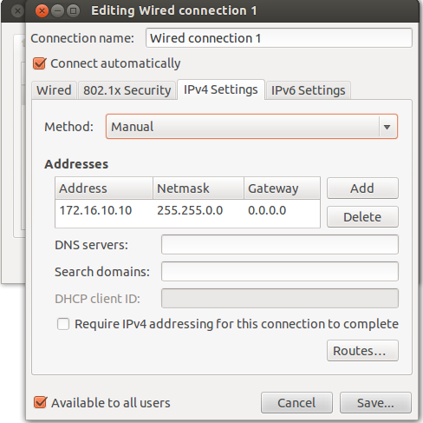
- Ensure that ros groovy is set in your environment, usually by including “source /opt/ros/groovy/setup.bash” in your bashrc. You may additionally need to source the setup file in the install folder, located at ~/catkin_ws/install/setup.bash.
- Messages/services must be built by issuing “catkin_make install” from the catkin_ws folder. More information on how to configure and use the workspace can be found in the ROS tutorials, and at http://wiki.ros.org/catkin/workspaces.
- Since inverse kinematic solutions are found using absolute coordinates, the virtual robot model has a tendency to flip joints in order to reach a new position. This can cause the robot to make dramatic movements to move the end effector a short distance. In the images below, the position of the hand was moved forward very slightly, yet the second and third joint made dramatic movements. Note the physical robot will not make this jump unless the A button is pressed to send the virtual joint positions to the controller.
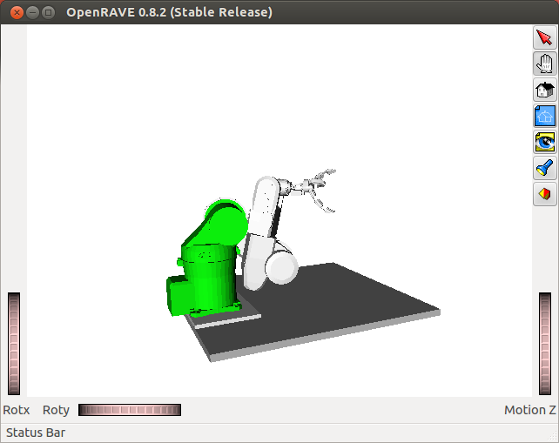
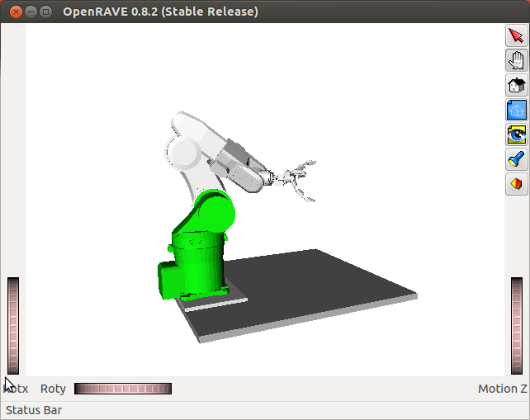
- When there is no possible joint solution to reach a point/orientation in space, the virtual robot will stall and a message saying “No IK solution found” will be printed to the roslaunch terminal. Motion is still possible, just not in that direction.

Controls

- Movement is controlled with the analog sticks sticks shoulder buttons/triggers. By default it is operated in a “pilot mode”, but this can be changed to an XYZ translation mode by uncommenting some lines in joy_to_rave.py.
- Pressing the A button will send the physical robot the position of the OpenRAVE model.
- Up and down on the D-Pad controls speed, though there is a cap that will not allow the arm to go too fast. Changing robot speed will print a message on the minicom terminal.
- Left and right control the 3D-printed claw. At the moment the claw only has an open and closed position. Note the possible issues with the claw in the section above.

Working with/Understanding the code

Messages

Messages sent to the Adpet controller are based on the V+ code from ROS Industrial. They are made up as 5 header values, with an optional 10 joint values, each 4 bytes in length. The header values are message length, message type, command type, message reply and message unused.

Message Length- Total length of the message being sent to the controller in bytes. Generally 20 bytes for robot settings and 60 bytes for robot motion commands.

Message Type- Indicated the type of message being sent. Message types were defined as follows:

Value | Type
1 | Robot motion defined by joint angles, includes one 32-bit floating point value for each joint. Angles are sent in radians.
2 | Robot motion defined by cartesian coordinates, includes XYZ coordinates as well as values for roll, pitch and yaw.
11 | Set Robot maximum speed, specified as an integer value. CAUTION, setting the speed value too high can cause dangerously fast robot motion
12 | Set Robot maximum acceleration, specified as a single integer value.
21 | Add length of end effector, specified as an integer value in millimeters.

Command type, message reply and message unused are not yet utilized. Since ROS.v2 code was experimental, their intended use was not clear.

Since python does not natively use single precision floats, the numpy module must be used to pack values as the correct size before transmission to the Adept controller. If desired, it would be possible to modify the ros.v2 code to take in doubles for joint angles, which would eliminate this issue.

ROS Message Graph/Node Explanations

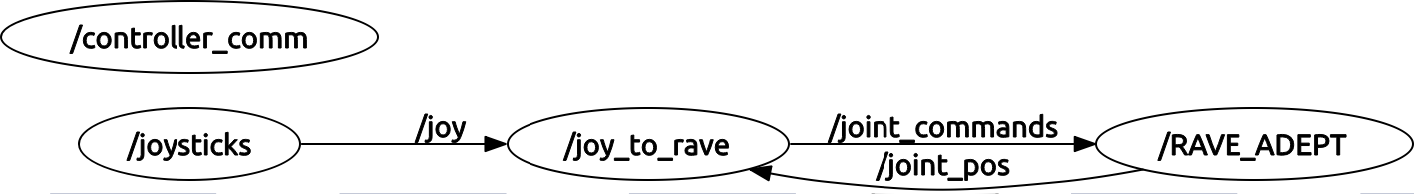
- RAVE_ADEPT is where the OpenRAVE window is spawned from. It keeps a virtual model of the robot and publishes messages containing joint positions. Many of the functions are not currently used, as the code was taken from another project and modified. Send_command and update_robot_joints are the callback functions responsible for simulated robot motion. The main thread loops at the bottom, publishing OpenRAVE joint positions to /joint_pos. RAVE_ADEPT will also send a service request to controller_comm, which forwards joint positions to the Adept smart controller.
- Joysticks is simply a joy node, that is it publishes messages containing gamepad button presses or stick movemnets.
- joy_to_rave receives gamepad messages and /joint_pos messages. It will then send any offsets back to RAVE_ADEPT. It also handles claw movement and sends messages to the servo board.
- controller_comm receives service requests for joint movement or parameter configuration. It maintains the socket connection to the smart controller. Both RAVE_ADEPT and the previously mentioned manual entry prompt use this node.
  - As a note, implementation of the controller feedback client would fulfill a similar role as controller_comm, however it should probably publish physical robot positions instead of provide a service.

Using the Adept Controller

Controller command can be found in the V+ Operating System Reference Guide, with detailed explanations of how the OS works in the corresponding Users Guide. These guides could be found on the internet, but are also included in the osu_ros_adept repository under the Docs folder. Some useful commands are below:

To save programs in controller
store <program name> = <routine name>, <routine name> ..
ex store rosx.v2 = a.ros, ros.msg.create, ros.read.4bytes, ros.read.joints, ros.rev.bytes, ros.srv.cmd, ros.srv.fdb, ros.stop, ros.set.speed, ros.set.accel, ros.set.tool

These should not usually need to be changed. It appears however that when they are changed, you cannot simply store them under the original filename. Saving modified code requires a sequence of storing the code under a new name, deleting the old version, and then renaming the new code. This is accomplished by issuing store, fdelete and frename commands.

To write code, the V+ text editor must be used, invoked by the “see” command, followed by the name of the program in memory. There is some instruction on the use of see in the OS users guide. Since there appears to be no easy way to copy files directly onto or off of the controller, care should be taken when editing code by creating backups as you progress.

Other thoughts

There is a program from the ros.v2 code that sends messages back to the host computer indicating joint positions, called ros.srv.fdb (feedback). This functionality has not been utilized, but could be used by creating a ROS node to read the joint values from the controller and then broadcast them as ROS messages.

Updates (Anthoney, Jackson, Trystan, Jie)
Turns out that when “roslaunching” the setup, python print commands no longer print to the screen. To get such messages, you must use rospy.logerr() (for errors) or a similar command for info. We added a socket connection error message in controller_comm_client.py using rospy.logerr()

